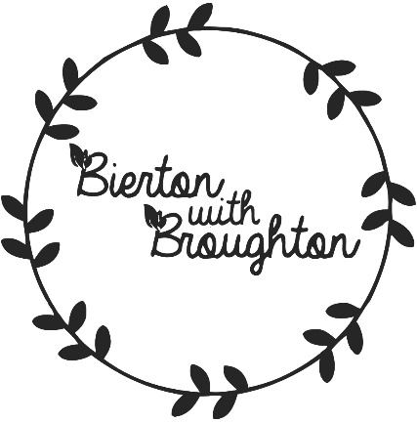

News Update

16th March 2022
The Steering Group have now submitted the Neighbourhood Plan to Buckinghamshire Council and Regulation 16 will commence shortly.

