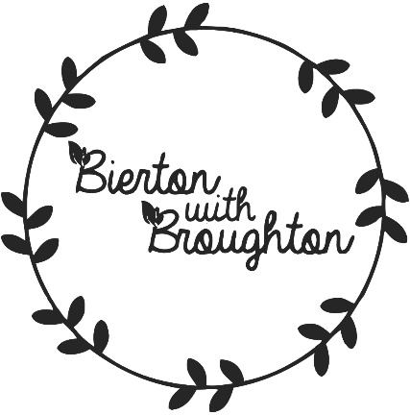

News Update

27th March 2020
​We are still doing our best to conduct the work required for the Neighbourhood Plan using email and video conferencing during the Covid-19 government enforced social distancing/self-isolation.

We hope you are all staying safe and well at home.

